Explain whether each of the following event represents (i) a shift of the [demand curve](https://moodle.unive.it/mod/resource/view.php?id=38952), or (ii) a movement along the [demand curve](https://moodle.unive.it/mod/resource/view.php?id=38952).

a) a store owner finds that customers are willing to pay more for umbrellas on rainy days.

b) When Circus Cruise Lines offered reduced prices for summer cruises in the Caribbean, their number of bookings increased sharply.

c) People buy more long-stem roses the week of Valentine's Day, even though the prices are higher than at other times during the year.

d) A sharp rise in the price of gasoline leads many commuters to join carpools in order to reduce their gasoline purchases.

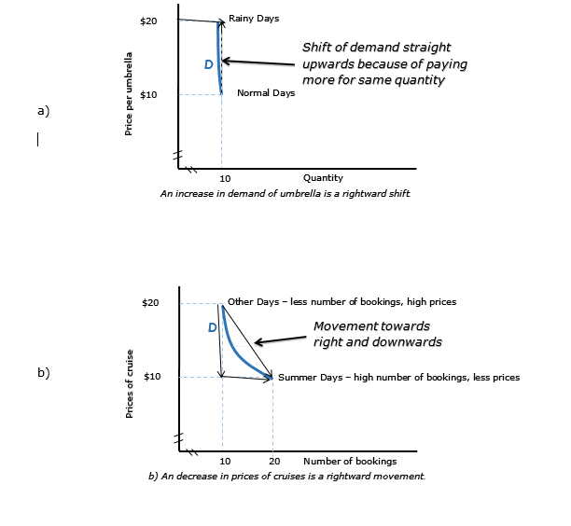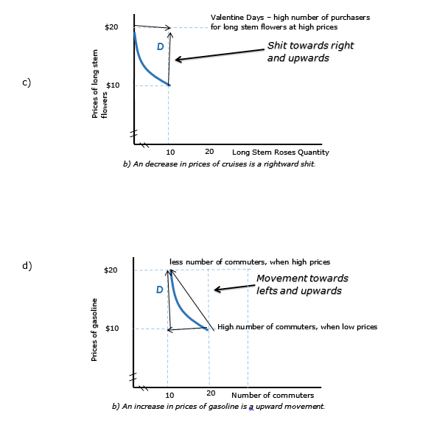

This blue line in graph c) is initial data line, new shit line is at point where two arrows heads are meeting.